**CMIS 242 6382 Intermediate Programming – Project 4**

Student Name: Xingyi Zhang

Instructor: Vladimir Gubanov

Date: July 13, 2020

**Test Cases and Result Displays**

1. **Default setting result:**

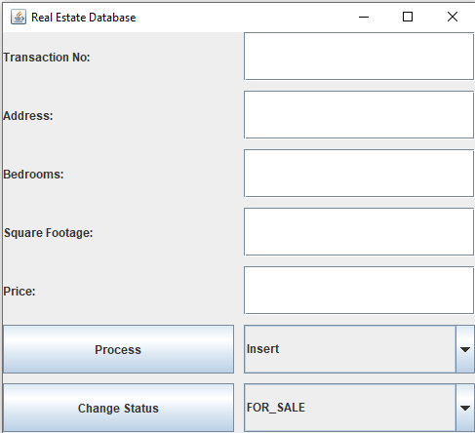

Analysis:

All labels, Text Fields, buttons, and default combo box settings are correct as directed.

This test case is passed.

1. **Insert property information into the database:**

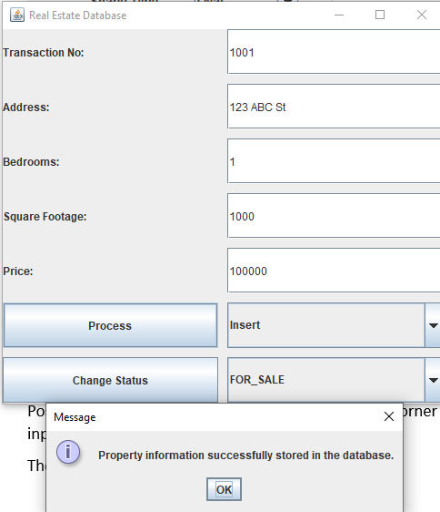

Analysis:

Input values are in correct format and the property information is shown to be successfully stored in the database.

The program has passed this test case.

1. **Change the format of sqft and price to be invalid format:**

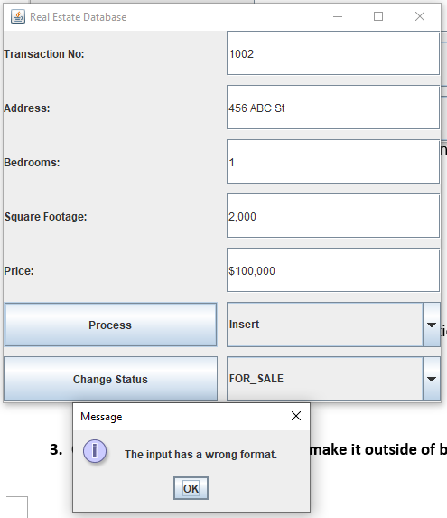

Analysis:

I have tested them separately and have proved that both 2,000 and ‘$’ are invalid input. The error was caught and the exception was thrown as shown above.

The program has passed this test case.

1. **Insert another property with its status changed:**

**Case 1 – When I filled in the information but clicked “Change Status” without clicking “Process”:**

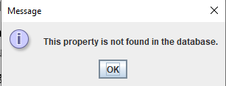

Analysis:

The property information was not saved in database, therefore, there would not be any status to change.

The program has passed this test case.

**Case 2 – When I clicked the process button, then clicked the “Change Status” button:**

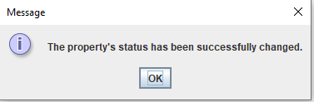

Analysis:

The property information was successfully stored in the database and then the status was successfully changed from “For Sale” to “Under Contract”.

The program has passed this test case.

**Case 3 – When I tried to click the “Process” button again without making further changes of the property information:**

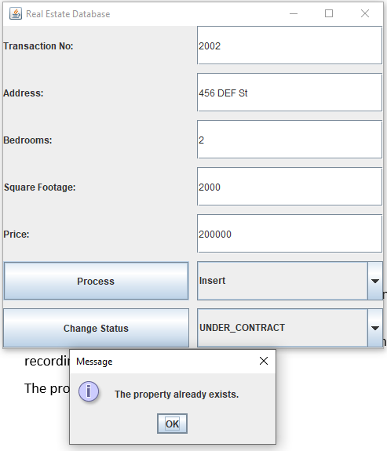

Analysis:

The property information was stored in the database already, no duplication insertion shall be made.

The program has passed this testcase.

**OVERALL ANALYSIS:**

The Program has successfully passed all test cases.